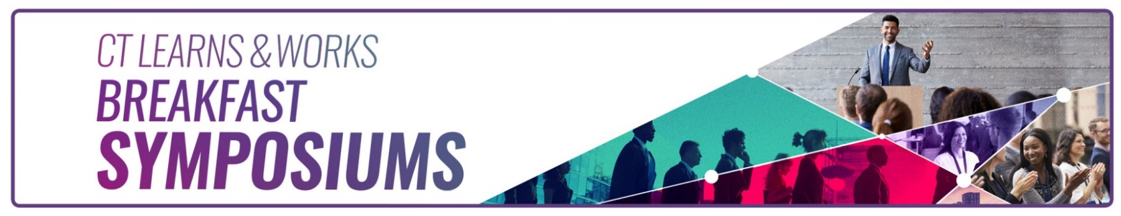
CT Learns and Works - Fall 2023 Breakfast Symposium

Manchester Community College
Great Path Academy Community Commons
Friday, October 27, 2023

Transitions: Support, Resources, and Opportunities for Individuals with Disabilities...
Agenda

7:30 a.m. Registration and Networking Breakfast

8:00 a.m. Opening and Welcome Remarks
Mark Polzella, Deputy Commissioner, CT Department of Labor

8:15 – 9:00 a.m. Keynote - Laura Albee, Visiting Assistant Professor of Social Work & Equitable Community Practice at The University of Saint Joseph
Supporting Special Needs Individuals in Academic and Professional Settings

9:05 – 9:45 a.m. Stefanie Knight (BRS services) and Angelo Vitale (BESB)

9:45 -10:00 a.m. Coffee Break

10:00-10:15 a.m. Current Labor Market Information – Patrick Flaherty, Research Director, CT DOL

10:15 -11:30 a.m. Panel (incl. Q&A)
Joe Navarra, Coordinator of Disability Services, Manchester Community College
Brian Gresko, DDS Transition Advisor – Project Search
Kathleen O’Connor, Principal Recruiter, TJX Companies, Inc.

11:30 a.m. Closing Remarks

Free registration includes breakfast and a morning of lively discussions and networking.

https://www.eventbrite.com/e/ct-learns-and-works-fall-2023-breakfast-symposium-tickets-66349082893?aff=oddtdtcreator

